An Internship Report

on

**Title of the Internship**

Submitted in partial fulfilment of the requirements

for the award of the degree of

**BACHELOR OF TECHNOLOGY**

in

**Computer Science and Engineering (Data Science)**

by

**B PURUSHOTHAM (214G1A3281)**

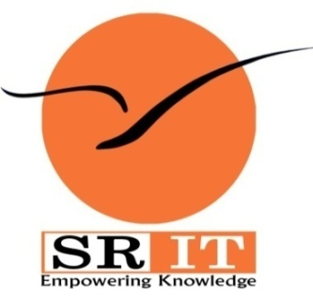

**DEPARTMENT OF COMPUTER SCIENCE AND ENGINEERING (DATA SCIENCE)**

**SRINIVASA RAMANUJAN INSTITUTE OF TECHNOLOGY**

**(AUTONOMOUS)**

**(Affiliated to JNTUA, accredited by NAAC with ‘A’ Grade, Approved by AICTE, New Delhi & Accredited by NBA (EEE, ECE & CSE))**

**Rotarypuram village, B K Samudram Mandal, Ananthapuramu-515701.**

**2023 - 2024**

**SRINIVASA RAMANUJAN INSTITUTE OF TECHNOLOGY**

**(AUTONOMOUS)**

**(Affiliated to JNTUA, accredited by NAAC with ‘A’ Grade, Approved by AICTE, New Delhi & Accredited by NBA (EEE, ECE & CSE))**

**Rotarypuram village, B K Samudram Mandal, Ananthapuramu-515701.**

**Department of Computer Science & Engineering (Data Science)**

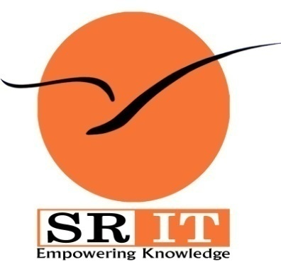

**Certificate**

This is to certify that the internship report entitled “Title of the Internship” is the bonafide work carried out by **B PURUSHOTHAM** bearing Roll Number 214G1A3281 in partial fulfilment of the requirements for the award of the degree of **Bachelor of Technology** in **Computer Science and Engineering (Data Science)** for <<four months from June 2022 to September 2022.>>

**Internship Coordinator Head of the Department**

Mr. P. Veera Prakash, M. Tech., (Ph.D.), Dr. P. Chitralingappa, M. Tech., Ph.D.,Assistant Professor & HOD of CSE Associate Professor

Date:  **EXTERNAL EXAMINER**

Place: Ananthapuramu

**PREFACE**

I did this Internship from MAY 2023 to JULY 2023 With the help of this technology,

real workflows are compared with theory, which leads to better transparency as well as insight into the processes. This is necessary because the reality of the processes usually does not correspond to the ideas of the process participants and the work steps in reality are usually much more complex. This internship project is a part of III - Year B. Tech program which I conduct at Srinivasa Ramanujan Institute of Technology – Ananthapuramu

AICTE has prepared a model curriculum with the help of prominent academicians of the country so that the country may produce competent employable graduates as per the needs of the industries. One of the best academicians in the India in Eduskills as for the AICTE curriculum they provided. The process mining was done in the platform of Celonis website, it helps companies achieve process excellence through its platform by eliminating operational friction with their Intelligent Business Cloud platform.

Brief overview of the company’s history:

* Who founded it
* What purpose and when

Company’s Mission Statement:

Business Activities:

**ACKNOWLEDGEMENT**

The satisfaction and euphoria that accompany the successful completion of any task would be incomplete without the mention of people who made it possible, whose constant guidance and encouragement crowned our efforts with success. It is a pleasant aspect that I have now the opportunity to express my gratitude for all of them.

It is with immense pleasure that I would like to express my indebted gratitude to my internship coordinator **Mr. P. Veera Prakash, Assistant Professor & HOD, Department of Computer Science and Engineering**, who has supported me a lot and encouraged me in every step of the internship work. I thank him for the stimulating support, constant encouragement and constructive criticism which have made possible to bring out this internship work.

I am very much thankful to **Dr. P. Chitralingappa, Associate Professor & HOD, Computer Science and Engineering (Data Science),** for his kind support and for providing necessary facilities to carry out the work.

I wish to convey my special thanks to **Dr. G. Balakrishna, Principal** of **Srinivasa Ramanujan Institute of Technology** for giving the required information in doing my internship. Not to forget, I thank all other faculty and non-teaching staff, and my friends who had directly or indirectly helped and supported me in completing my internship in time.

I also express our sincere thanks to theManagementfor providing excellent facilities and support**.**

Finally, I wish to convey my gratitude to my family who fostered all the requirements and facilities that I need.

**B.PURUSHOTHAM**

**(214G1A3281)**

**INDEX**

|  |  |  |
| --- | --- | --- |
| **Contents** | | **Page No.** |
| **List of Figures** | | vi |
| **List of Tables** | | vii |
| **List of Abbreviations** | | viii |
| **Nomenclatures** | | ix |
| Chapter 1 | Introduction – Briefing about different modules and importances of the Process mining | 1 |
| Chapter 2 | Technology- Explain about technologies that are required for the Process mining | 4 |
| Chapter 3 | Applications of the process mining  Explain different applications of the process mining |  |
| Chapter 4 | Modules Explanation |  |
| Chapter 5 | Real time example of the process mining  Every individual student must explain the usage of the process mining with unique example. |  |
| Chapter 6 | Learning outcomes of the Internship: Write the Learning outcomes of the Internship that are learned by the student. |  |
| Conclusion | | 33 |
| Internship certificate: Insert the Internship certificate and percentage and attendance certificate. | | 34 |
| References | |  |

**LIST OF FIGURES**

|  |  |  |
| --- | --- | --- |
| **Fig. No.** | **Description** | **Page No.** |
| 3.1 | Outage in linear networks | 18 |
| 4.1 | Output | 39 |
| 4.2 | Outage probability for Existing and Proposed system | 40 |

**LIST OF TABLES**

|  |  |  |
| --- | --- | --- |
| **Table No. No.** | **Table Name** | **Page No.** |
| 4.1 | Simulation parameters | 27 |

**LIST OF ABBREVIATIONS**

CBR Constant Bit Rate

CSI Channel State Information

EPA Equal Power Allocation

IEEE Institute for Electrical and Electronic Engineers

MANET Mobile Ad-hoc Network

NS-2 Network Simulator-2

OPA Optimal Power Allocation

OR-ICSI Optimal Routing –Instantaneous Channel State Information

OR-MCSI Optimal Routing –Mean Channel State Information

SNR Signal Noise Ratio

WMAN Wireless Metropolitan Area Networks

**NOMENCLATURE**

Rt Transmission price for Transaction t

Vj Node Voltage at Bus j

CHAPTER 1

INTRODUCTION

Do you know this? Sometimes work just isn't happening and the underlying problem is unclear. Normally you would spend hours searching in the depths of the process landscape, but there is a much simpler and more effective method: Process Mining. With the help of this technology, real workflows are compared with theory, which leads to better transparency as well as insight into the processes. This is necessary because the reality of the processes usually does not correspond to the ideas of the process participants and the work steps in reality are usually much more complex. You can imagine this like the promo pictures of empty vacation beaches, which are then totally overcrowded in reality.

Process mining is a process management technique. It aims to discover, monitor and improve process flows by extracting readily available knowledge from information systems event logs. Process mining provides companies with complete visibility into how processes really work. With these insights, companies can then identify opportunities for process optimization.

1.1 Modules

1.1.1 Process Mining

In this module we learned how to:

➢ Data transformation

➢ Data analysis

➢ Continuous monitoring

1.1.2 Process Mining (Cloud)

In this module we learned how to:

➢ App templates

➢ Extracting and loading data

##### 1.1.3 Processes Mining transparency

In this module we learned how to:

* **Automation Process Discovery**

* **Conformity Check**

* **Organization Mining**

**1.1.4 Process Mining is the MRI for processes** In this module we learned how to: ➢ **MRI Technology**

* **Risk of Confusion**

##### 1.1.5 Mining Algorithm

In this module we learned how to:

* **Deterministic Algorithm**

* **Heuristic Algorithm**

* **Genetic Algorithm**

##### 1.1.6 Starting a Project in mining

In this module we learned how to:

**Determining problem**

* **Defining the Data**

* **Pilot Project**

* **Accepting Truth**

##### 1.1.7 Industrial Usage of Mining

In this module we learned how to:

* **PRODUCTION**

* **FINANCING**

* **TELECOM**

##### 1.1.8 Process Mining Software’s

In this module we learned how to:

* **Process Detection**

* **Conformity Testing**

* **Performance Analysis**

##### 1.1.9 Software Key Functions

In this module we learned how to:

* **Identifications**

* **Optimization**

##### 1.1.10 Process Mining Software Providers

In this module we learned how to:

➢ **Different Software Providers**

## **CHAPTER 2**

##### TECHNOLOGY

###### Process Mining Technologies

Process mining **applies data science to discover, validate and improve workflows**. By combining data mining and process analytics, organizations can mine log data from their information systems to understand the performance of their processes, revealing bottlenecks and other areas of improvement.

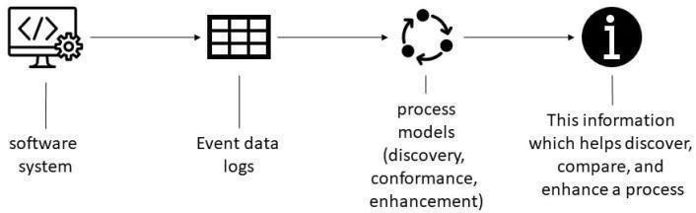

Fig -1.1

1. App templates

With the **Process Mining** service in Automation Cloud, you can create new process apps based on process-specific app templates. An app template contains a predefined set of dashboards and KPIs for process analysis and can be used as the starting point for creating your process apps. If available, an app template can include a built-in connector for a specific combination of a process and source system.

2. Extracting and loading data

When creating a process app, you can upload data from .csv or .tsv files, or you can set up a connection to a source system using the extraction tools CData Sync or Theobald Xtract Universal. You can also use **DataBridgeAgent** to use custom .mvp connectors to upload data from your source system.

3. Editing data transformations

Transformations are applied to the data stored in the database to make sure the data adheres to a data schema which can be loaded in the **Process Mining** process app. In **Process Mining**, you can customize the transformations to adapt them to your data schema.

4. Customizing process apps

Dashboard editor

After creating a process app from an app template, you can edit the dashboards to customize the process app to your business needs. The **Dashboard editor** provides various options to create different views, and to organize, group, and filter data.

Data Manager

The **Data Manager** enables you to customize the data used in your process app. With **Data Manager** you can edit data fields and metrics to change the display names used in your app. Besides, you can toggle fields to be visible or not.

5. Root cause analysis

With **Root cause analysis**, you can compare the influence of case properties on a certain behavior to find significant data influencers for specific process situations. A set of cases is defined based on the period filter. This selection is called *Reference cases*. Within this set of cases, you can select the behavior that you want to analyze.

6. Managing access control for process apps

**T**he **Admin Console** module enables you to manage access by assigning roles to users or groups. The permissions model allows you to integrate all your employees using **Process Mining** based on your business requirements.

## CHAPTER 3

# APPLICATIONS

Process mining applies data science **to discover, validate and improve workflows**. By combining data mining and process analytics, organizations can mine log data from their information systems to understand the performance of their processes, revealing bottlenecks and other areas of improvement. Process mining is beneficial for many situations in large organizations. Areas where process mining can be actively applied include the following

* Automation This is about understanding the actual processes, variations and opportunities to be successful in RPA projects.
* The reporting of complete process KPIs and dashboards for a given process.

* The Digital Transformation to understand the "big picture" - how businesses operate, what needs to be prioritized and transformed.
* Scaling optimization efforts across multiple business operations and locations and supporting process control through the use of Data.
* Capture processes anywhere in the enterprise with little human effort.

* Identify bottlenecks, deviations, and inefficient processes to be reconsidered or automated. ➢ Continuous monitoring and measurement of improvements.

* Simplify compliance, with complete audit trails.

* Delivering the full context and end-to-end perspective required for process improvements.
* Identify the most valuable and effective processes for using automation.

## CHAPTER 4

MODULES EXPLANATION

#### Module 1: Process Mining

Process mining **applies data science to discover, validate and improve workflows**. By combining data mining and process analytics, organizations can mine log data from their information systems to understand the performance of their processes, revealing bottlenecks and other areas of improvement. Process mining leverages a data-driven approach to process optimization, allowing managers to remain objective in their decision-making around resource allocation for existing processes. Process mining focuses on different perspectives, such as control-flow, organizational, case, and time. While much of the work around process mining focuses on the sequence of activities—i.e. control-flow—the other perspectives also provide valuable information for management teams.

#### Module 2: Process Mining Cloud

With the **Process Mining** service in Automation Cloud, you can create new process apps based on process-specific app templates. An app template contains a predefined set of dashboards and KPIs for process analysis and can be used as the starting point for creating your process apps. If available, an app template can include a built-in connector for a specific combination of a process and source system .It offers out-of-the box app templates for several processes and source systems that you can use as the starting point for creating your process apps. You can customize these app templates to your business needs and publish them with a set of dashboards and KPIs to enable business users to monitor and analyze the processes in detail. When creating a process app, you can upload data from .csv or .tsv files, or you can set up a connection to a source system using the extraction tools CData Sync or Theobald Xtract Universal. You can also use **Data Bridge Agent** to use custom .mvp connectors to upload data from your source system.

##### Module 3: Processes Mining transparency

Process mining is a process management technique. It aims to discover, monitor and improve process flows by extracting readily available knowledge from information systems event logs. Process mining provides companies with complete visibility into how processes really work. With these insights, companies can then identify opportunities for process optimization. Process mining involves several steps

The automated process discovery - extraction of process models from an eventlog.

&

The conformity check - monitoring deviations by comparing model and protocol.

##### Module 4: Process Mining is the MRI for processes

Process mining technology could also be compared to magnetic resonance imaging (MRI) technology, which collects information from the body's cells to create an image - only in a business environment. Doctors then use this MRI image to diagnose health conditions. Process mining works on a similar principle: It collects data from the smallest part of process activities and assembles it into a picture that companies can use to diagnose the state of their workflows. Process mining is changing the way companies operate and manage their business operations. In their

9

quest for process quality, companies can use process mining to really get to know their process, evaluate it against the ideal process model, and optimize it as needed.

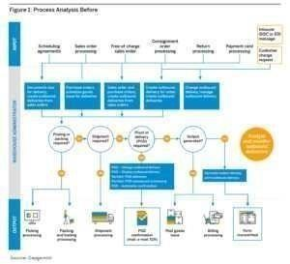

##### Module 5: Mining Algorithms

The mining algorithm determines how process models are created. The best known categories are:

1. Deterministic algorithms: Determinism means that an algorithm produces only defined and reproducible results. It always delivers the same result for the same input.

The deterministic algorithm was one of the first algorithms capable of handling concurrency. It takes an event log as input and computes the order relation of the events contained in the log.

1. Heuristic Algorithms: Heuristic mining also uses deterministic algorithms.

However, they refer to the frequency of events and traces to reconstruct a process model. A common problem in process mining is that real-world processes are very complex and their discovery leads to complex models. This complexity can be reduced by neglecting rare paths in the models.

3.Genetic Algorithms: They use an evolutionary approach that mimics the process of natural evolution. They are not deterministic. Genetic mining algorithms follow four steps: Initialization, Selection, Reproduction, and Termination.

1 2



Fig -2.1

##### Module 6: Starting Project in Mining

To start a project in the stream of process mining one need to follow some

basic requirements they are classified as follows.

**Determine Problem**: Identify the problem of importance to the business that can realistically be addressed with process mining.

**Identify the Data**: Identify the data sources that need to be fully understood to address the business process issues under consideration.

**Setting Pilot Project**: Set up a pilot project to prove the potential value of a process mining solution.

**Accept Truth**: Accepting the results of the analysis, as process mining provides, among other things, a clear picture based on facts.

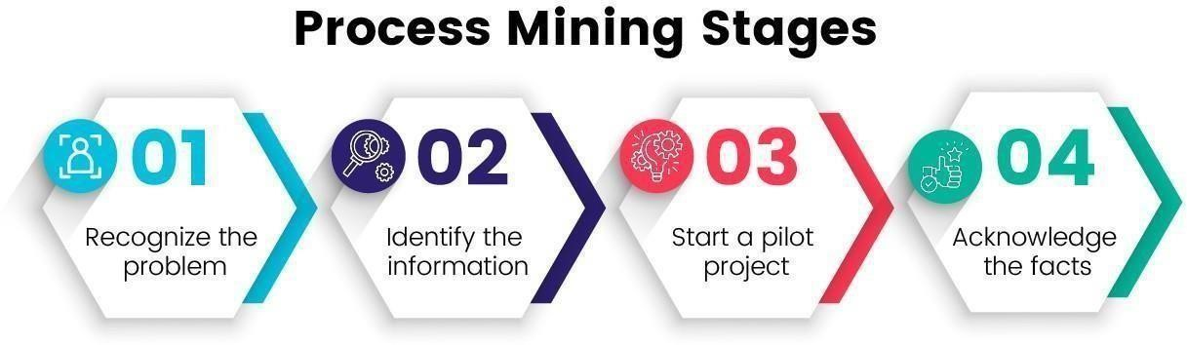

Fig -2.2

##### Module 7: Industrial Usage of Mining

**Production**

In the manufacturing industry, timely and accurate delivery to a customer is the goal. When a company has multiple factories in different regions, there are usually differences between the reliability of deliveries. It is fairly easy to see that they exist, but it is more difficult to understand exactly where or why they are happening. Process mining can be used to compare the performance of different locations, down to individual process steps, including duration, cost, and the person performing the step. All event data available in the systems is suitable for use. In this way, facts can be generated.

**Banking and finance**

In the financial sector, it is important to comply with rules and regulations and to be able to provide evidence of this. By using the event data from the systems, individual cases can also be visualized as a process flow. It can be shown how often

**Telecommunication**

Telecommunications is a highly competitive sector worldwide. The ability to improve operational processes is key to success and profitability. Process mining helps telecom companies gain visibility into geographically dispersed operations, identify bottlenecks, and ensure that customers receive products and services on time

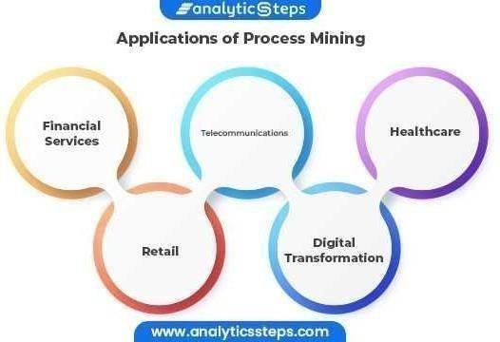

Fig -3.1

**Module 8: Process Mining Software’s**

A process mining solution should have strong detection capabilities. It should be able to search event logs to track what employees are actually doing and then create an appropriate process model by generating process maps of the entire business flow. In addition, the solution should have robust conformance checking that analyzes event logs to ensure that actions match process models. Third, a process mining solution needs performance analysis and improvement capabilities that analyze potential inefficiencies within an event log to determine if and how they can be improved, and then make improvements based on real process data. Ultimately, though, which software is right for the job depends on the size of the company, its business needs, and its goals.

##### Module 9: Process Mining Software Key Functions

If your selected process mining software fulfills these key functions, then you have already made a good choice. However, you should always keep in mind that your company's ability to measure, monitor and optimize business processes has a direct impact on revenue and customer satisfaction. Therefore, it is important to choose the right process mining solution wisely to ensure that all business goals are optimally met. If necessary, an expert can also be consulted.Identify bottlenecks & process optimization opportunities Provide insights into failed process steps Ensure end-to-end view of the entire process Monitor performance indicators in real time Perform data cleansing Compliance analysis & gap analysis Provide continuous business process monitoring in realtime Improve process model.

##### Module 10: Process Mining Software Providers

**The following are the Process Mining Software Providers in the Market**

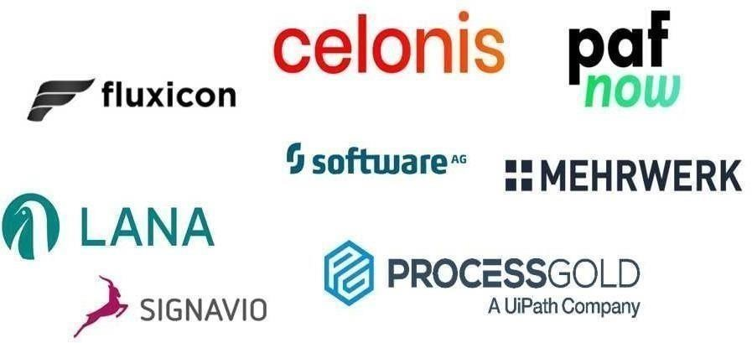

Fig -3.3

## CHAPTER 5

#### LEARNING OUTCOMES

* Gain an overall understanding of basic Process Mining concepts.
* Become familiar with Mining core services and tools.
* Learn the architectural principles of the process Mining.
* Understand and be able to explain Process Mining and compliancemeasures.
* Understand the Process Mining budget and pricing philosophy.

Engage in hands-on practice to hone key skillsLearn the knowledge and skills required to take the Process Mining Virtual Internship Certified .

#### CHAPTER 6

#### **CONCLUSION**

❖ By doing this internship we learnt

* The importance of Process Mining.
* Tools that helps us to optimize our service costs.
* Software Production and Estimation.
* Processing the Huge data.
* And other different Services that are provided in Mining

INTERNSHIP CERTIFICATE

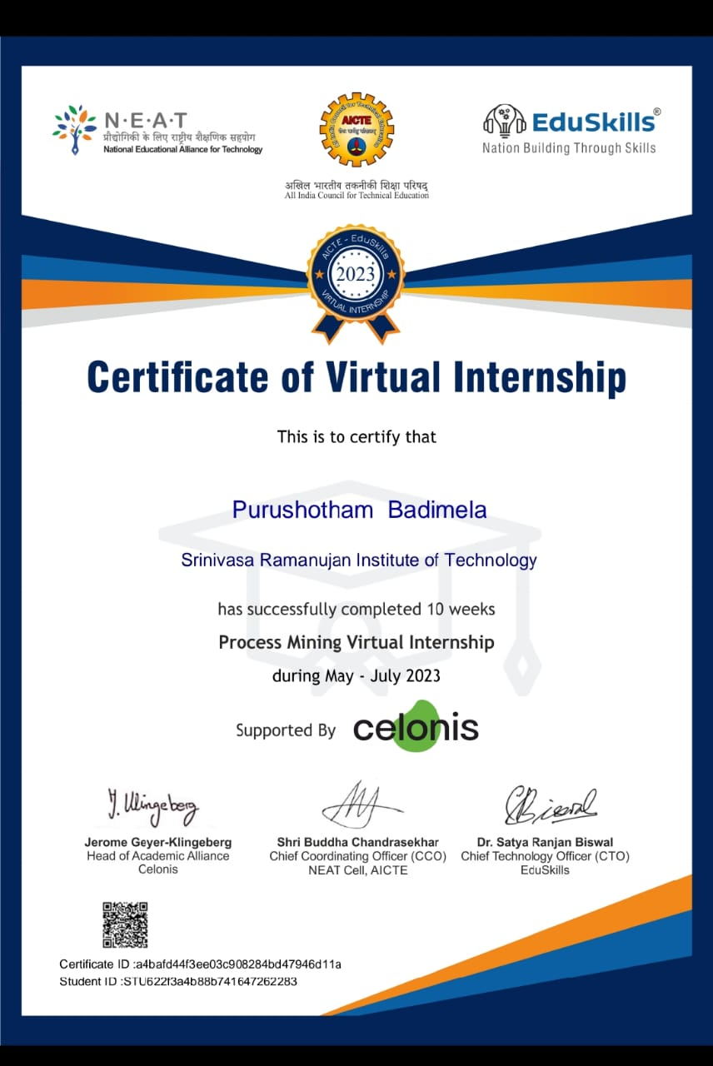

# REFERENCES

➢ The Reference of this internship was done in the Celonis platform link https://academy.celonis.com/learn/dashboard

➢ Introduction to process mining -https://academy.celonis.com/learn/course/introduction-to-process-mining/intr oduction-to-process-mining/course-outline?client=academic-alliance-celonis

➢ Process mining fundamental -https://academy.celonis.com/learn/learning-path/process-mining-fundamenta ls-for-student